Optimized drivelines, aerodynamics and specifications for industry-leading efficiency

**New Generation DAF trucks: powering customer success**

**As part of its DAF Transport Efficiency philosophy, DAF is introducing a full suite of new innovations for its New Generation DAF series to power customer success. Driveline and aerodynamic optimizations result in up to 3% fuel efficiency gain, on top of the 10% for the New Generation DAF, thereby setting a new industry-standard. The even richer specification and the new PACCAR Connect fleet management system offer additional opportunities to enhance operating efficiency. The next chapter of the New Generation DAF is available for ordering now.**

* The power of efficiency
  + PACCAR MX-11 and MX-13 engine optimizations
    - New valve timing (Miller), coolant pump and air compressor
    - Optimized turbo and EGR system
    - Prepared for B100 FAME biodiesel
  + Rear axle innovations
    - New pinion design for enhanced strength and durability
    - New rear axle ratios for the next level in down speeding
  + Side skirts now also available for Lowdeck tractor models
  + Standard specification fully tuned to fuel efficiency and C02 reduction
    - DAF Digital Vision System
    - Predictive Cruise Control
    - Full Aero Package
    - Low rolling resistance tyres
  + 10 year PACCAR Connect subscription
* The power of safety
  + A full range of Advanced Driver Assistance Systems as standard
    - Advanced Emergency Braking system
    - Enhanced protection of vulnerable road users
    - Event Data Recorder
    - DAF Side & Turn Assist
* The power of comfort
  + Even lower noise levels thanks to next level in down speeding
  + New standards in drivability
  + New Truck Navigation App and Connected truck navigation

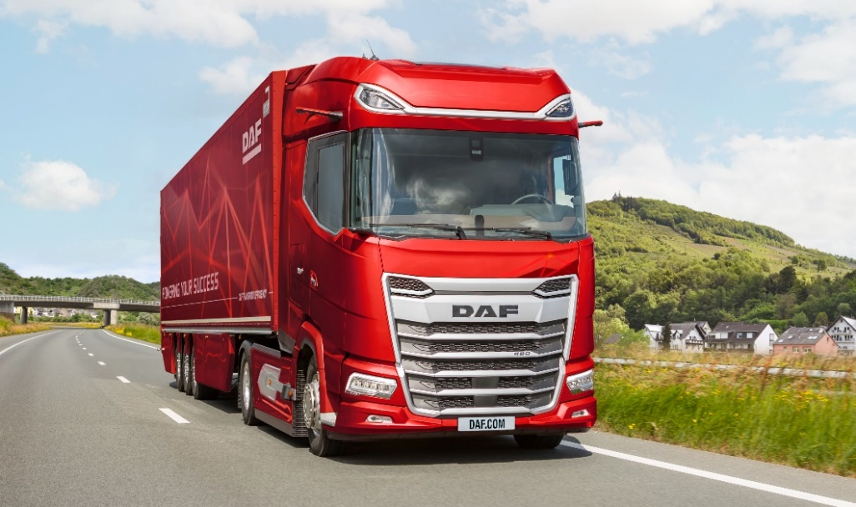

**New Generation DAF trucks are powering customer success**

DAF introduced its industry-leading New Generation XF, XG and XG+ vehicles for long and heavy haulage in 2021, followed by the versatile XD series for regional and vocational applications in 2022. All New Generation DAF vehicles are developed according the new EU Masses & Dimension regulations, resulting in best-in-class aerodynamics, fuel efficiency and low CO2 emissions. The new design includes large windows and low window belt lines and – in combination with digital cameras – adds to unsurpassed direct vision, thus safety. Superb spaciousness, fit and finish, quality and driving characteristics make the New Generation DAF trucks the preferred choice of the driver as well.

Because of the new standards set in efficiency, safety and comfort, the New Generation DAF XD, XF, XG and XG+ trucks were elected ‘International Truck of the Year’ for both 2022 and 2023, followed by multiple prestigious recognitions by leading transport publications and organizations throughout Europe.

Thanks to a comprehensive range of innovations, the best trucks on the market now become even better for both operator and driver. They represent the next chapter of the New Generation DAF, which is available for ordering now.

**The power of efficiency**

All New Generation DAF trucks benefit from perfect aerodynamics, highly efficient PACCAR MX-11 and MX-13 engines (power ratings from 270 kW/370 hp up to 390 kW/530 hp) and a range of advanced driver assistance systems, resulting in an impressive fuel efficiency improvement of up to 10%. Now, an additional 3% gain can be realized through driveline and aerodynamic enhancements.

Various New Generation DAF models comply with the Maut Class 3 requirements, which can result in German road tax savings of thousands of euro’s per year.

The optimized driveline efficiency of the DAF XD, XF, XG and XG+ is realized through new engine valve timing according the Miller principle. In addition, a dual drive coolant pump is applied, which is electrically powered at low load cooling conditions, and belt driven when high cooling performance is needed. For highest efficiency, a 2 cylinder clutched air compressor is mounted. Turbo and EGR systems have been updated to seamlessly fit the new valve timing. Latest generation fuel injectors support excellent efficiency, reliability and durability.

**New Generation DAF XDC Construction Truck**

Axle innovations

DAF is also introducing several innovations to its popular SR1344 rear axle program. A new pinion design offers enhanced strength and durability and also allows application for the highest PACCAR MX-13 power rating of 390 kW/530 hp. This ensures that all PACCAR MX engines can optimally benefit from DAF’s down speeding philosophy.

A new shifting strategy of the transmission and the new engine optimizations make it possible to apply the 2.05:1 rear axle ratio in combination with the most popular 315/70R22.5-tyre size for highest fuel efficiency for all engines of 4x2 tractor models. Cruising at 85 km/u will result in an even 7% lower rpm (950 instead of 1,030).

In addition, the SR1344 axle program has been completed with a 2.64:1 axle ratio, with a grinded gear design for highest efficiency.

To optimize the efficiency of the New Generation DAF models, the DAF Digital Vision camera system (replacing the conventional mirrors), Predictive Cruise Control and low resistance tires become standard on 4x2 and 6x2 versions* to offer another 6% fuel efficiency gain. For customers who didn’t order these features before, total fuel consumption and CO2 benefit will be up to 9%. In daily practice, the fuel efficiency gain could be even be larger, as also the aerodynamic package is standard.

10 year PACCAR Connect

All New Generation DAF trucks come with a 10 year PACCAR Connect subscription. This new online fleet management platform provides real-time information on the performance of the entire fleet, individual vehicles as well as drivers, thereby helping operators to optimize efficiency and returns. The platform also enables efficient over-the-air vehicle updates.

A major benefit of PACCAR Connect is the easy integration with existing logistic applications from so called ‘third parties’, setting a new standard in fleet management systems. This makes it easier to monitor all logistical processes from one device, adding to the comfort of the driver. To achieve maximum efficiency, PACCAR Connect also makes use of ‘geofencing’, which notifies the home base or destination whenever a truck is nearing a delivery location.

B100 FAME biodiesel

To further power customer success, B100 FAME biodiesel versions of the PACCAR MX engine will become available as of early 2025. For Lowdeck tractors side skirts are now available, offering additional opportunities to enhance vehicle efficiency.

**The power of safety**

New Generation DAF trucks set the standard when it comes to direct and indirect view, thanks to amongst others, the low window belt lines, the kerb view window and the sophisticated digital cameras. The extremely strong cab structure, the patented Cab Displacement System and the Controlled Displacement Steering System ensure the XD, XF, XG and XG+ are leading the way in passive safety as well. A full range of ex-factory Advanced Driver Assistant Systems (ADAS) support industry-leading active safety.

The **Advanced Emergency Braking System** (AEBS) of the latest generation is equipped with radar sensors (2 long and 1 short range) and a camera, providing full autonomous emergency braking to assist with collision avoidance of vulnerable road users in front of the vehicle. An additional radar takes care of the new **Drive-off Assist** function to detect and warn the driver of any close-by vulnerable road users at stand-still or drive-off.  
The **Event Data Recorder** records images and data when the AEBS brake warning is activated and the **DAF Side & Turn Assist** warns in case pedestrians, cyclists or vehicles are in the vehicle’s blind spots, including all the way to the back of the trailer.

Furthermore, each New Generation DAF will come with **Speed Limit Recognition** informing the driver about actual speed limits and warning in case of over speeding, while the **Lane Departure Warning System** helps to avoid dangerous situations by warning for potentially unintended lane changes.

The new **Rear View Camera** shows what’s happening at the rear of the truck on a display in the cab. The **High Beam Assist** (optional) automatically switches off the high beam when other vehicles are oncoming or ahead. And as continuation of the functionality employed with previous DAF trucks, an **Emergency Stop Signal** alerts other road users through flashing hazard lights when the truck strongly decelerates.

In addition, new features are standard to further enhance safety related to the driver. The new **DAF Drowsiness Detection** assesses the driver’s alertness and gives an alert when a break is needed, while a preparation for an **Alcohol Interlock** is available to facilitate installation of a device that ensures a negative alcohol test outcome before the engine can be started.

**The power of comfort**

The New Generation DAF XD, XF, XG and XG+ are recognized by drivers for their unmatched comfort when driving, resting and sleeping.

The new driveline updates result in even lower noise levels at cruising conditions as it operates at even lower rpms. Engine optimizations in combination with the new shifting strategy of the transmission add to enhanced drivability thanks to an even smoother shifting performance.

**New Generation DAF trucks offer premium driver comfort**

The new PACCAR Connect online fleet management platform features Connected Truck Navigation and allows for full route planning to be sent from the home base directly onto the secondary screen in the truck for highest driver comfort. Among the features are last and first mile routing options which add to vehicle efficiency as well as driver convenience.

*In summary, the best trucks on the market have become even better. This further strengthens the industry-leading position of the DAF XD, XF, XG and XG+ in terms of operating efficiency, safety and driver comfort, powering customer success.*

**DAF Trucks N.V.** — a subsidiary of PACCAR Inc, a global technology company that designs and manufacturers light, medium and heavy-duty trucks. DAF provides a full range of tractor units and vocational trucks, offering the right vehicle for every transport application. DAF is also a leading provider of services, including MultiSupport repair and maintenance contracts, financial services from PACCAR Financial and a first-class parts delivery service from PACCAR Parts.

Hanover, 16 September, 2024

***Note to editors only***

For more information:

DAF Trucks N.V.

Corporate Communication Department

Rutger Kerstiens, +31 40 214 2874

[www.daf.com](http://www.daf.com)

*\*) Depending on market and application*